Experiment No- 3
Online Bus Booking System
AIM:
To develop an online bus ticket booking website using HTML, CSS, and JavaScript to search buses and routes. The system allows users to book and cancel tickets and view booking details.
Procedure:
- Design the bus booking page using HTML.
- Style the page using CSS.
- Use JavaScript to enter route and passenger details.
- Display booking confirmation.
- Test the application in a browser.
Sample Code:
<!DOCTYPE html>
<html>
<body>
<h2>Bus Ticket Booking</h2>
<input id="from" placeholder="From">
<input id="to" placeholder="To">
<button onclick="bookBus()">Book Ticket</button>
<p id="result"></p>
<script>
function bookBus() {
let f = document.getElementById("from").value;
let t = document.getElementById("to").value;
if (f && t && f.toLowerCase() !== t.toLowerCase()) {
document.getElementById("result").innerHTML =
"Bus ticket booked: " + f + " to " + t;
} else {
document.getElementById("result").innerHTML =
"Enter valid source and destination";
}
}
</script>
</body>
</html>
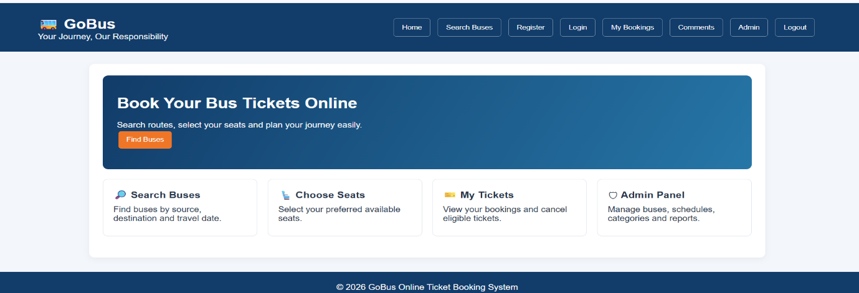
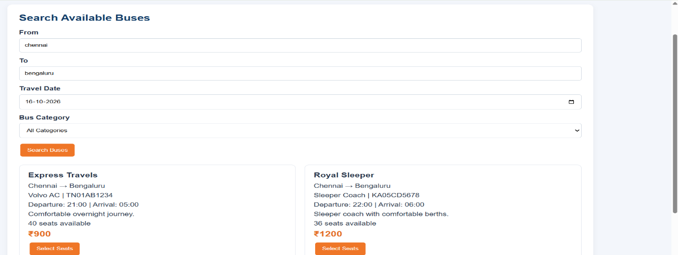
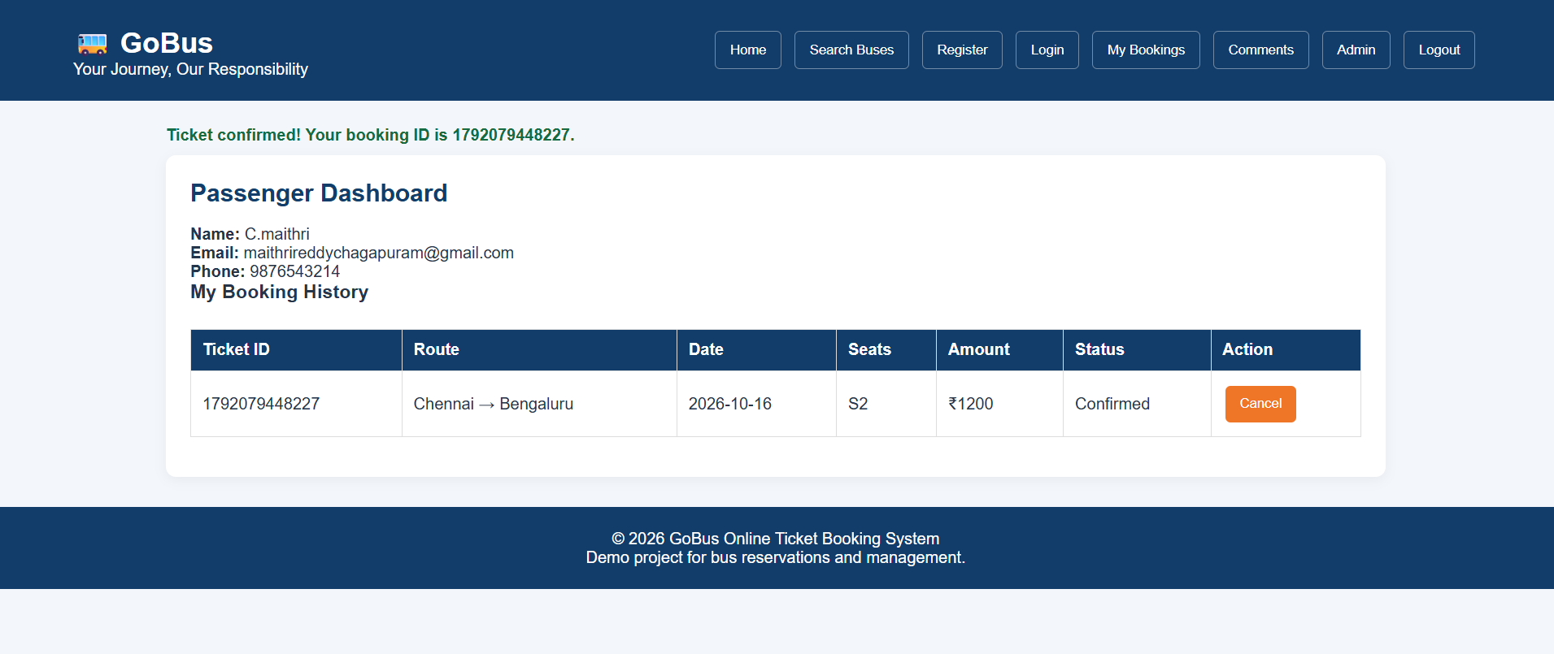
Result:
Thus, the bus ticket booking website was developed successfully to search buses, manage ticket bookings, cancel tickets, and display booking details.

